
COMSATS University Islamabad (CUI)
Project Proposal
for
PropBot

AI-Powered RFP & Proposal Automation Platform

Version 1.1

By
Alina Raza CIIT/FA23-BSE-015/ISB
Anna Munir CIIT/FA23-BSE-019/ISB
Ayesha Noor CIIT/FA23-BSE-025/ISB

Supervisor
Dr. Memoona Malik

Bachelor of Science in Computer Science (2023-2027)
Application Evaluation History
Comments | Action Taken
Project Idea & Aim: most proposed functions were standard document-processing and LLM-assisted tasks; the technical contribution beyond an LLM/API-based workflow was not clearly identified. | Added a dedicated “Project Contribution” section that explicitly lists nine original contributions, including structured compliance evaluation, requirement traceability and readiness validation, and team-built benchmarks, that go beyond simply orchestrating LLM API calls.  [Section 10 “Project Contribution”, Page 12]
Problem Complexity & FYP Depth (major concern), uploading an RFP and using an LLM to summarize, extract, or generate content can largely be implemented using existing LLM APIs, prompting, and document-processing libraries; insufficient technical depth for a three-member, one-year FYP. | Redesigned the Compliance Matrix Generator so requirements are converted into structured constraints (parameter, operator, value, unit); numeric requirements are evaluated with rule-based logic and unit normalisation, while descriptive requirements use embedding retrieval with reranking against datasheet evidence, replacing simple prompting.  [Section 7.3 “Module 3: Compliance Matrix Generator”, Page 7]  Extended scope with two new modules so the work is sized appropriately for a three-member team: bid-task/deadline automation and a companion mobile application for reviewer approvals.  [Section 7.17 “Module 17: Bid Tasks and Deadlines” & Section 7.18 “Module 18: Mobile Application”, Page 11]
Suggestion: introduce substantial original technical work such as domain-specific retrieval/evaluation, structured requirement reasoning, automated validation, optimisation, or another technically challenging component. | Added three new measurable objectives implementing the suggested components: BO-10 (unique requirement IDs linked across checklist, compliance, proposal and BOQ for traceability), BO-11 (automated readiness validation that blocks packaging until outstanding issues are cleared), and BO-14 (team-built labelled benchmarks from sample RFPs and OEM datasheets to verify parsing, checklist and compliance accuracy).  [Section 3.1 “Objectives”, Page 4]  The requirement-traceability and readiness-validation logic referenced above is described in full under the Project Contribution section.  [Section 10.7 “Requirement Traceability and Readiness Validation”, Page 13]
The industry problem is relevant and the platform has practical value; however, the scope appeared largely achievable through existing LLM APIs, prompting, document processing, and a conventional web interface. Insufficient original technical depth was demonstrated; the project requires substantial technical/research components beyond API integration and feature development. | Added a section mapping the technical work to core coursework (Software Requirement Engineering, Artificial Intelligence, Machine Learning Fundamentals, and others).  [Section 11 “Relevance to Course Modules”, Page 14]  Objectives BO-10–BO-14 give each new component a measurable, verifiable target (accuracy, traceability coverage, benchmark results) rather than a feature-only claim.  [Section 3.1 “Objectives”, Page 4]
Verdict: Rejected – Insufficient FYP Depth / Scope for Three Members. | This revised scope document is resubmitted for re-evaluation with the changes summarised in the rows above, concentrated in the following sections/pages: Section 3.1 (Page 4); Section 7.3, 7.17 and 7.18 (Page 7); Section 10 and 10.7 (Page 12 and 13); and Section 11 (Pages 14).

Supervised by
Supervisor’s Name: Dr. Memoona Malik


Signature: ______________________
Table of Contents
Abstract 2
1. Introduction 3
2. Problem Statement 3
3. Problem Solution/Objectives of the Proposed System 4
3.1 Objectives 4
4. Related System Analysis/Literature Review 5
5. Vision Statement 5
6. Scope 6
7. Modules 6
7.1 Module 1: RFP Parser and Classifier 6
7.2 Module 2: Submission Checklist Generator 7
7.3 Module 3: Compliance Matrix Generator 7
7.4 Module 4: Technical Evaluation Criteria Analyser 7
7.5 Module 5: HLD Diagram Generator 8
7.6 Module 6: Technical Proposal Generator 8
7.7 Module 7: BOQ Generator 9
7.8 Module 8: Responsibility Matrix Generator 9
7.9 Module 9: Project Vault and Centralised Storage 9
7.10 Module 10: Submission Package Builder 9
7.11 Module 11: Knowledge Base and Past Project Reuse 10
7.12 Module 12: Company and Organisation Management 10
7.13 Module 13: User and Role Management 10
7.14 Module 14: Template Library Management 11
7.15 Module 15: Audit Log and Activity Tracking 11
7.16 Module 16: Analytics Dashboard 11
7.17 Module 17: Bid Tasks and Deadlines 11
7.18 Module 18: Mobile Application 12
8. System Limitations/Constraints 12
9. Data Gathering Approach 12
10. Project Contribution 12
10.1 End-to-End RFP Workflow Automation 12
10.2 RAG-Based Proposal Generation Using Organisational Knowledge 12
10.3 Structured Compliance Evaluation 13
10.4 Automatic HLD Diagram Generation 13
10.5 Structured Human Review and Approval Workflow 13
10.6 Centralised Project Vault and Organisational Knowledge Retention 13
10.7 Requirement Traceability and Readiness Validation 13
10.8 Bid Task and Deadline Management 13
10.9 Companion Mobile Application 13
11. Relevance to Course Modules 13
11.1 Software Engineering 13
11.2 Software Requirement Engineering 14
11.3 Software Design and Architecture 14
11.4 Artificial Intelligence 14
11.5 Machine Learning Fundamentals 14
11.6 Database Systems 14
11.7 Web Technologies and Advanced Web Technologies 14
11.8 Mobile Application Development 14
11.9 Information Security 14
11.10 Computer Networks 15
11.11 Software Project Management 15
12. Tools and Technologies 15
13. Project Stakeholders and Roles 16
14. Module based Work Division 17
15. WBS and Gantt Chart 18
15.1 GANTT CHART 21
16. Mockups 22
16.1 Mockup 1 22
16.2 Mockup 2 23
16.3 Mockup 3 24
16.4 Mockup 4 25
16.5 Mockup 5 26
16.6 Mockup 6 27
16.7 Mockup 7 27
16.8 Mockup 8 27
16.9 Mockup 9 27
17. References 28
18. Plagiarism Report 29

Project Category:
Web Application/Web Application based Information System
Problem Solving and Artificial Intelligence
Simulation and Modeling
Mobile Application

Abstract
Preparing responses for RFPs (Request for Proposals) is one of the most time-consuming responsibilities for presales engineers in IT companies. Engineers must manually read lengthy documents, extract technical requirements, prepare compliance sheets, create checklists, design network diagrams, and write detailed proposals. Most companies still rely on personal laptops, emails, and scattered files to manage this work, causing inefficiency, inconsistent proposal quality, missed submission documents, and loss of expertise when employees leave the company.
The current process is repetitive, slow, and requires significant manual effort. Managing multiple active RFPs simultaneously becomes difficult, deadlines are harder to meet, and new opportunities may be missed due to workload. At present, there is no single AI platform that completely automates the proposal generation process.
PropBot is an AI-powered platform with a web application and a companion mobile application, designed to automate major parts of the presales process for IT companies, particularly in the telecommunications sector. The system can automatically read and classify RFP documents, generate submission checklists, develop compliance matrices, create Bills of Quantities (BOQs), and produce technical proposals. It also stores project-related data in a permanent centralized vault to preserve organisational knowledge. The mobile application supports reviewer approvals, checklist document capture, task and deadline tracking, and push notifications, using the same backend as the web application.
The platform uses Retrieval Augmented Generation (RAG) to retrieve relevant information from past proposals and improve the quality of future generated proposals. All generated proposals require human review and approval before finalisation. PropBot also supports common telecom client formats such as PTCL, OGDCL, Zong, and Telenor, while allowing deployment on a company’s own infrastructure to ensure data security.

Introduction
PropBot is an AI-powered RFP and proposal automation platform developed as an industry-focused Final Year Project. The project is designed to improve the proposal preparation process in telecom and IT companies where engineers regularly respond to client-issued RFPs. In many organizations, preparing a proposal is still a highly manual task that requires engineers to review long documents, understand technical requirements, prepare compliance responses, create BOQs, and gather supporting documents. This process often takes several days and becomes difficult to manage when multiple RFPs are active at the same time. Manual handling can also lead to inconsistent proposal quality, disorganized records, and loss of valuable company knowledge when employees leave.

To address these issues, PropBot automates major stages of the proposal development workflow. The platform can analyze RFP documents, extract important requirements, generate compliance checklists, and assist in drafting technical proposals using previously approved company data. It also supports BOQ generation, HLD network diagram creation, and preparation of final submission packages in a structured format. Another key objective of the system is knowledge centralization, where all project files and generated documents are stored in a secure shared repository for future reuse. The platform is specifically designed for telecom-focused IT companies and supports workflows commonly followed by organizations such as PTCL, OGDCL, Zong, and Telenor. The companion mobile application supports reviewer approvals, checklist document capture, task and deadline tracking, and push notifications, using the same backend as the web application. Technically, the system is developed using FastAPI and React for the web application and React Native (Expo) for the mobile application, with AI functionalities powered through LangChain, LangGraph, ChromaDB, PostgreSQL, and the OpenAI API. The project is being developed collaboratively by Alina Raza, Anna Munir, and Ayesha Noor, with each member contributing to different areas of the platform’s design and implementation.

Problem Statement
In telecom-focused IT companies, responding to RFPs is still a highly manual and time-consuming process. When organizations receive RFPs from clients such as PTCL, OGDCL, or Zong, presales engineers are required to handle most of the work manually without the support of a dedicated automation system. Engineers often depend on personal folders, previous files, spreadsheets, and email conversations to prepare proposal submissions. One of the main difficulties is understanding the RFP document itself, as these files are usually very lengthy and contain technical, commercial, financial, and legal information mixed. Engineers must spend hours carefully reviewing the document to identify the sections relevant to their responsibilities.
Another major challenge is creating the submission checklist. Most RFPs require vendors to submit many mandatory documents, including certificates, purchase orders, affidavits, and engineer profiles. Since this process is managed manually, there is always a risk of missing an important document, which can result in bid rejection. Preparing the compliance matrix is also a repetitive and error-prone task. Engineers must compare each client’s requirement with the proposed solution and manually assign compliance statuses such as Fully Compliant, Partially Compliant, or Non-Compliant. For large-scale projects, this process can take many hours and directly impacts whether the company qualifies for the project.
Proposal writing itself creates additional workload for pre-sales teams. Although many proposal sections remain similar across projects, engineers still rewrite large portions of content for every submission. In addition, supporting deliverables such as BOQs, responsibility matrices, and HLD network diagrams must also be prepared separately for each project. Many of these tasks follow repetitive formats but are still recreated manually every time. Another serious issue is the absence of a centralized knowledge management system within many organizations. Proposal files and project documents are often stored on personal devices or scattered across email threads, making them difficult to access later. When experienced employees leave the company, valuable proposal knowledge and previous work are frequently lost. As a result, new engineers often must restart similar work from the beginning, leading to duplicated effort and reduced efficiency.
In addition, presales teams usually handle several active RFPs at the same time, and closing dates are tight. Tasks such as document collection and proposal review are tracked informally through email and messages, and reviewers or approvers are often unavailable at a desk, which delays approvals and causes missed deadlines.
PropBot is proposed as a unified AI-powered platform designed to streamline and automate these processes while improving consistency, efficiency, and knowledge retention within telecom IT companies.

Problem Solution/Objectives of the Proposed System
PropBot is an AI-powered platform, with a web application and a companion mobile application, developed to automate the complete RFP-to-submission workflow for telecom IT companies. The system is designed to reduce manual effort, improve proposal consistency, and centralize organizational knowledge within a single platform. The workflow starts when a presales engineer uploads an RFP document into the system. PropBot automatically analyses the document, classifies its sections, and extracts important technical and pre-sales-related information. Instead of manually reviewing large RFP files, engineers can quickly access the relevant content in a structured and organized format. After the RFP is parsed, the system creates tasks with due dates from the extracted closing date so that the team can track the bid deadline.
After analyzing the RFP, the platform generates a submission checklist containing all mandatory supporting documents required for the bid. Engineers can monitor completed and pending items directly through the system, reducing the chances of missing critical documents during submission. For compliance evaluation, engineers enter the equipment or solution they plan to propose, such as routers, switches, or network devices. PropBot then converts the requirements into structured rules and compares them against the proposed model’s specification, matching descriptive requirements to evidence from the datasheet, and automatically creates a compliance matrix. Each requirement is marked with a compliance status such as Fully Compliant, Partially Compliant, or Non-Compliant, and each rating carries a reason and evidence, while non-compliant items are highlighted for review.
The platform also assists in technical proposal generation using a Retrieval-Augmented Generation approach. Previously approved proposals stored in the company knowledge base are searched to retrieve relevant information for generating new proposal drafts. Engineers can review, edit, and refine the generated content before it moves to the approval stage. A reviewer verification process is included to ensure that proposals are checked before final submission. In addition, the system automates supporting deliverables such as BOQs and responsibility matrices using predefined templates. PropBot can also generate High-Level Design diagrams and connectivity descriptions based on structured network information provided by engineers. Reviewers and engineers can approve sections, tick checklist items, attach documents using the phone camera, and receive alerts through the companion mobile application.
At the final stage, all required files are uploaded into the platform for verification. The system checks the uploaded documents against the submission checklist and ensures that no mandatory item is missing before preparing the final package. A readiness check run before packaging lists anything that still blocks submission. PropBot then generates a structured ZIP file containing all organized submission documents. Another important feature of the platform is the centralized project vault, where all RFPs, proposals, diagrams, and submission packages are permanently stored for future reuse and organizational knowledge retention.

Objectives
BO-1: Reduce the average time required to prepare an RFP response from 3–7 days to less than 8 hours.
BO-2: Automatically classify and extract technical requirements from uploaded RFP documents within 60 seconds.
BO-3: Generate submission document checklists automatically with an extraction accuracy of at least 90%.
BO-4: Automatically generate a compliance matrix with FC, PC and NC classifications after the engineer provides proposed equipment details, with a reason and supporting evidence shown for each rating.
BO-5: Generate complete technical proposal drafts using a RAG-based pipeline with a faithfulness score greater than 0.85 measured using RAGAS evaluation.
BO-6: Automatically populate BOQ templates and generate responsibility matrices using predefined standard formats.
BO-7: Generate High-Level Design (HLD) network diagrams from structured engineer input without requiring manual diagram creation in Visio.
BO-8: Maintain a permanent centralised project vault searchable by client name, equipment type, and project date.
BO-9: Implement a human review and approval workflow to ensure that no generated document is exported or submitted without engineer verification and approval.
BO-10: Assign a unique ID to each accepted RFP requirement and link it to its checklist item, compliance row, proposal section and BOQ line so that uncovered requirements can be identified.
BO-11: Run a readiness check before packaging that lists every blocking issue (missing mandatory documents, unresolved NC items, unapproved sections) and prevents the submission package from being built until blockers are cleared.
BO-12: Provide a mobile application for reviewer approvals, checklist document capture, task tracking and push notifications, using the same backend and role-based access as the web application.
BO-13: Automatically generate bid tasks with due dates from the extracted RFP closing date and show overdue tasks and tasks per engineer.
BO-14: Create our own benchmarks (labelled test data) from sample RFPs and OEM datasheets to verify the accuracy of RFP parsing, checklist extraction and compliance results.

Related System Analysis/Literature Review
Table 1 Related System Analysis with proposed project solution

Application Name | Weakness | Proposed Project Solution
Jasper AI | Jasper AI is mainly designed for content writing and marketing purposes. It cannot understand telecom RFP structures or generate technical documents such as compliance matrices, BOQs, or HLDs. It also does not provide central project storage for long-term knowledge retention. | PropBot is designed specifically for telecom presales processes. It can automatically read RFP documents, generate compliance matrices, BOQs, and HLDs, while also storing all project data in a centralized repository for future reuse.
Proposify | Proposify helps teams create proposal documents, but engineers still need to manually prepare technical content and compliance details. The platform does not automate proposal generation using past company knowledge or RFP analysis. | PropBot automates major proposal generation tasks using Retrieval Augmented Generation (RAG). It retrieves information from previous proposals and generates technical documents automatically, reducing manual effort and saving significant time.
Microsoft | Microsoft Copilot can assist with general writing tasks, but it is not designed for telecom presales engineering workflows. It cannot analyse RFP documents, generate compliance matrices, or create BOQs based on project requirements. | PropBot uses the uploaded RFP as the foundation for the entire proposal process. The system automatically analyses requirements and generates technical documents such as compliance sheets, BOQs, and proposal content in a structured workflow.
OpenAI | ChatGPT can generate text responses, but it does not maintain long-term project memory or provide centralized project management. It also lacks approval workflows, document governance, and structured storage for proposal-related data. | PropBot combines AI-powered proposal generation with centralized storage and governance features. All generated documents are stored permanently, reviewed by humans before approval, and managed within a single secure platform.

Vision Statement
For presales engineers at telecom IT companies who spend 3 to 7 days manually processing every RFP they receive such as reading requirements, building checklists, filling compliance matrices, drawing network diagrams, and writing proposals from scratch, the PropBot is an AI-powered web and mobile platform that reads any RFP automatically, generates the submission checklist, compliance matrix, technical proposal, BOQ, HLD diagram, and responsibility matrix, and packages everything into a verified submission folder, turning a 3-day manual process into an 8-hour guided workflow, with a mobile application that lets reviewers and engineers approve, capture documents and track deadlines away from their desks. Unlike Jasper AI, Proposify, Microsoft Copilot, and ChatGPT, which each solve only a small piece of the problem and require engineers to do most of the work manually, our product PropBot is the only platform that handles the complete RFP-to-submission workflow end to end, stores every project in a central vault so institutional knowledge is never lost, and is built specifically for the telecom sector with pre-loaded templates for PTCL, OGDCL, Zong, and Telenor.

Scope
PropBot is a web and mobile platform that automates the complete RFP response workflow for presales engineers at telecom IT companies. When an engineer uploads an RFP, the system reads it automatically, sorts every section into the right category such as technical, commercial, financial, legal, or presales and pulls out all technical specifications, equipment requirements, and submission document requirements in one go. It then builds a live checklist the engineer can tick off as they collect documents, and when the engineer enters their proposed equipment models, the system compares each one against the RFP requirements and generates a compliance matrix marked as Fully Compliant, Partially Compliant, or Non-Compliant, exported as an Excel file.
For document generation, PropBot uses the company's own past approved proposals as a knowledge base and writes each section of the new technical proposal automatically. The engineer reviews and edits each section, a reviewer approves it, and only fully approved proposals can be exported as Word or Pdf files. The system also auto-fills the Bill of Quantities Excel template, generates the responsibility matrix from a standard template, and creates the High-Level Design network diagram from the engineer's description of the existing and proposed network.
Every project and every document is stored permanently in a central vault on the company's own server, so nothing is ever lost. When all final documents are ready, the submission package builder verifies them against the checklist and packages everything into a structured ZIP folder. The admin layer handles company setup, user roles, template management per telecom client, audit logging, and a management analytics dashboard. A companion mobile application lets reviewers and engineers approve proposal sections, capture checklist documents, view tasks and alerts, and check project status from their phones. The system also creates bid tasks with due dates from the extracted RFP closing date, and assigns a unique ID to each accepted requirement so that it can be traced to its checklist item, compliance row, proposal section and BOQ line. A readiness check before packaging lists any blocking issues and prevents the submission package from being built until they are cleared.
Optional enhancements (implemented only if time permits): detection of vague or duplicate requirements in Module 1; draw.io XML export in Module 5; a win/loss relevance boost in Module 11 and similar past project suggestion in Module 9; and an offline mode for the mobile application.
Things outside the scope of this project include CRM integration, automated cost calculations, multi-language support, cloud deployment, HR, payroll, staff timetabling or other ERP functions, live OEM vendor API integration, and offline mobile operation. The final deliverable is a fully working, locally deployed web application with a companion mobile application, demonstrated live.

Modules

Module 1: RFP Parser and Classifier
FE-1.1: The system shall accept RFP files in .pdf and .docx formats up to 50 MB.
FE-1.2: The system shall extract raw text from uploaded PDFs using the PyMuPDF library and from Word files using python-docx.
FE-1.3: The system shall classify every extracted section into one of five categories, technical, commercial, financial, legal, presales, using a zero-shot classification pipeline built on the facebook/bart-large-mnli model.
FE-1.4: The system shall apply Named Entity Recognition (NER) using spaCy's en_core_web_trf model to extract equipment names, quantities, protocol names, and specification values from the technical section.
FE-1.5: The system shall detect the delivery scope (supply, deploy, configure, migrate) using keyword pattern matching combined with dependency parsing on the extracted technical text.
FE-1.6: The system shall detect the telecom client format (PTCL, OGDCL, Zong, Telenor) using string matching against a pre-defined client format dictionary and apply the corresponding parsing rules.
FE-1.7: The system shall complete full RFP parsing and display classified output within 60 seconds of upload.
FE-1.8: The engineer shall be able to manually correct or re-label any misclassified section through the UI.
FE-1.9: The system shall extract the bid closing date and time from the parsed RFP text; if it is not detected, the engineer shall enter it manually.
FE-1.10: The system shall assign a unique requirement ID to each extracted requirement and store it in a project-scoped requirement registry; the engineer shall be able to accept, edit, merge or reject extracted requirements.
NFR-1.1: Section classification accuracy shall be at least 85% when evaluated on a test set of 20 sample RFPs from different telecom clients.

Module 2: Submission Checklist Generator
FE-2.1: Extraction of all submission document requirements from parsed RFP text using GPT-4o-mini with structured JSON output prompt; returns fields: document_name, mandatory (true/false), responsible_team
FE-2.2: Classification of each item as mandatory or optional using modal verb detection via spaCy en_core_web_trf dependency parser, "shall" and "must" map to mandatory, "may" and "should" map to optional
FE-2.3: Assignment of responsible team (presales, sales, finance) inferred from surrounding RFP section context using the M1 classifier output
FE-2.4: Live tick-off interface for engineers to mark items as collected and attach the corresponding document file
FE-2.5: Real-time counter displaying collected vs outstanding items, updated on every tick-off event
FE-2.6: Blocking of submission package generation if any mandatory item remains uncollected, enforced at API level in M10
FE-2.7: Manual addition of custom checklist items by the engineer for requirements not detected automatically

Module 3: Compliance Matrix Generator
FE-3.1: The engineer shall input proposed OEM vendor names and model numbers for each equipment category extracted by M1.
FE-3.2: The system shall obtain the specification of each proposed model as a structured parameter table (parameter, value, unit), either from the pre-loaded internal specification database or from an OEM datasheet uploaded by the engineer, whose extracted parameters the engineer shall confirm before use.
FE-3.3: The system shall convert each numeric or boolean RFP requirement into a structured constraint (parameter, operator, value, unit) and evaluate it against the model's specification using rule-based comparison with unit normalisation (for example Mbps and Gbps), assigning FC if the constraint is satisfied, PC if it is partly satisfied according to a defined rule table, and NC if it is not satisfied or the parameter is missing.
FE-3.4: The system shall calculate and display the overall compliance percentage as: (FC count + 0.5 × PC count) / total requirements × 100.
FE-3.5: All NC items shall be highlighted in red with a disqualification risk label.
FE-3.6: The engineer shall be able to manually override any compliance rating and enter a justification note.
FE-3.7: The system shall export the completed matrix as a formatted .xlsx file using openpyxl.
FE-3.8: The system shall support simultaneous comparison of up to three alternative OEM models for the same requirement set.
FE-3.9: For descriptive requirements that cannot be converted into constraints, the system shall retrieve the most relevant datasheet passages using text-embedding-3-small embeddings with cross-encoder reranking and assign a rating with the retrieved passage as evidence.
FE-3.10: The system shall store, for every compliance row, a short reason and the evidence reference, and shall mark low-confidence rows as "needs review".
NFR-3.1: Compliance comparison shall complete within 30 seconds of model submission.

Module 4: Technical Evaluation Criteria Analyser
FE-4.1: Extraction of the scoring table from the parsed RFP using GPT-4o-mini, returning structured JSON with fields: criterion, marks_available, qualifying_threshold, disqualification_threshold
FE-4.2: Display of marks available per document category and per compliance requirement in a sortable table
FE-4.3: Display of qualification threshold and disqualification score parsed directly from the RFP scoring section
FE-4.4: Real-time running score computation using formula: running_score = Σ marks_available[i] for all checklist items where collected = true, updated on every M2 tick-off event via WebSocket push
FE-4.5: Warning notification triggered when running_score < qualifying_threshold
FE-4.6: Display of message "No technical evaluation criteria detected in this RFP" when no scoring table is found

Module 5: HLD Diagram Generator
FE-5.1: Structured JSON input form for existing network devices with fields: device_type, vendor, model, connections_to[]
FE-5.2: Import of proposed equipment from M3 compliance matrix output or manual entry
FE-5.3: Conversion of device JSON into a Mermaid.js graph definition and rendering as an HLD network topology diagram using the Mermaid rendering engine
FE-5.4: Use of standard IEEE network topology icons for device types: switch, router, firewall, server, storage
FE-5.5: Export of rendered diagram as PNG using Playwright headless browser rendering pipeline
FE-5.6: Export of editable draw.io XML file generated from the same device graph JSON (Optional enhancement: implemented only if time permits)
FE-5.7: Generation of written connectivity description (2–4 paragraphs) using GPT-4o-mini, with the device graph JSON as input context

Module 6: Technical Proposal Generator
FE-6.1: The system shall chunk all knowledge base documents into segments of 400 tokens with 50-token overlap using LangChain's RecursiveCharacterTextSplitter.
FE-6.2: The system shall embed all chunks using OpenAI's text-embedding-3-small model (1536 dimensions) and store the resulting vectors in ChromaDB with metadata fields: source_file, section_type, telecom_client, year, win_loss.
FE-6.3: At generation time, the system shall convert the engineer's input requirements into an embedding using text-embedding-3-small and retrieve the top 5 most similar chunks from ChromaDB using cosine similarity search.
FE-6.4: The system shall rerank the retrieved chunks using the cross-encoder/ms-marco-MiniLM-L-6-v2 model before passing them to the generator.
FE-6.5: The system shall generate each proposal section: Executive Summary, Technical Approach, Proposed Solution, Methodology, as a separate GPT-4o-mini call, each with a section-specific system prompt and the reranked chunks as context.
FE-6.6: All generated sections shall conform to a Pydantic v2 output schema with fields: section_name, content, word_count, source_chunks_used.
FE-6.7: The engineer shall review and edit each section individually in the TipTap rich text editor before approval.
FE-6.8: A reviewer shall approve or request changes in each section. The proposal cannot be exported until all sections are approved. The reviewer may perform this action from the web or the mobile application.
FE-6.9: The system shall export the approved proposal as a formatted .docx file using python-docx with the company's branded template.
FE-6.10: Every exported document shall include a footer: "Generated using PropBot AI, Reviewed and approved by [engineer name] on [date]."
FE-6.11: The system shall link each generated proposal section to the requirement IDs it addresses.
FE-6.12: The system shall run a rule-based coverage check that lists any accepted requirement ID not linked to at least one proposal section.
NFR-6.1: Full proposal draft generation shall complete within 60 seconds of submission.

Module 7: BOQ Generator
FE-7.1: The system shall maintain a library of pre-loaded BOQ Excel templates per telecom company (PTCL, OGDCL, Zong, Telenor), stored as .xlsx files managed through M14.
FE-7.2: The system shall auto-populate the BOQ template with equipment model names, descriptions, and quantities extracted from the M3 compliance matrix output using openpyxl.
FE-7.3: All costing, margin, and formula columns shall remain blank in the exported file for manual completion.
FE-7.4: The engineer shall be able to add, edit, or remove line items before export.
FE-7.5: The system shall export the completed BOQ as a formatted .xlsx file.

Module 8: Responsibility Matrix Generator
FE-8.1: The system shall maintain a pre-loaded standard responsibility matrix template with at least 24 common rows covering: kickoff, HLD sign-off, delivery, installation, configuration, testing, documentation, and handover.
FE-8.2: The system shall auto-assign each row to responsible parties: IT company, OEM vendor, customer, presales, using a rule-based mapping table stored in the database.
FE-8.3: The engineer shall be able to add project-specific rows and modify any responsibility assignment before export.
FE-8.4: The system shall export the completed matrix as a formatted .xlsx file using openpyxl.
FE-8.5: The admin shall be able to update the standard template rows through M14.

Module 9: Project Vault and Centralised Storage
FE-9.1: Permanent per-project folder structure on company server: /RFP, /Drafts, /Approved, /Submission; paths scoped by org_id/project_id
FE-9.2: Automatic saving of all generated and uploaded documents to the correct vault folder on every export or upload event
FE-9.3: Full-text search across all projects using PostgreSQL tsvector and tsquery indexing, filterable by client name, telecom company, date range, equipment type, and project status; results returned within 3 seconds for up to 500 projects
FE-9.4: Similar past project suggestion on new RFP upload using cosine similarity search (threshold ≥ 0.70) on text-embedding-3-small embeddings of past project summaries stored in ChromaDB; top-3 results surfaced to the engineer (Optional enhancement: implemented only if time permits)
FE-9.5: On-premise-only storage, all file writes directed to local server paths; no external API calls for storage operations
FE-9.6: Project status field with values: active, submitted, won, lost; updated manually by the engineer or Org Admin
FE-9.7: Traceability view showing, for each requirement ID, its linked checklist item, compliance row, proposal section and BOQ line, together with a list of requirements that have no link.

Module 10: Submission Package Builder
FE-10.1: Multi-file upload interface for engineers to add all final submission documents to the project submission area
FE-10.2: Cross-checking of uploaded files against M2 mandatory checklist using filename normalisation and document-type classification via GPT-4o-mini; matched items marked as fulfilled automatically
FE-10.3: Display of blocking error list for any unfulfilled mandatory checklist items before packaging is allowed
FE-10.4: ZIP archive generation using Python zipfile module with standard folder structure: /Technical_Proposal, /Commercial, /Annexures, /Reference_Documents
FE-10.5: Permanent saving of ZIP and all contents to M9 project vault under /Submission folder
FE-10.6: Auto-generation of a submission summary .docx listing every included file with its name, size, and the checklist item it satisfies
FE-10.7: Readiness check run before packaging. Blockers (packaging is prevented): unfulfilled mandatory checklist items; NC compliance items without an engineer justification; proposal sections not yet approved. Warnings (shown but do not block): running evaluation score below the qualifying threshold (from M4); accepted requirements not linked to any output. The system shall display the blocker and warning list.

Module 11: Knowledge Base and Past Project Reuse
FE-11.1: Automatic ingestion of approved proposal into ChromaDB on project submission — chunked using RecursiveCharacterTextSplitter (chunk size: 400 tokens, overlap: 50 tokens), embedded using text-embedding-3-small (1536 dimensions)
FE-11.2: Metadata tagging per ingested chunk: telecom_client, equipment_types, service_type, year, win_loss
FE-11.3: Relevance boost of +0.15 applied to cosine similarity scores of chunks tagged win_loss = "won" during M6 retrieval ranking (Optional enhancement: implemented only if time permits)
FE-11.4: Manual upload of past proposals by engineer with manual metadata tagging via admin form
FE-11.5: Admin view, re-tag, and delete operations on all knowledge base documents via the admin panel
FE-11.6: Knowledge base coverage dashboard showing document count per telecom client and equipment category, queried from ChromaDB collection metadata

Module 12: Company and Organisation Management
FE-12.1: The super admin shall create company workspaces with name, logo, and initial admin user, stored as an organisations table row in PostgreSQL.
FE-12.2: All database queries, ChromaDB collections, and file storage paths shall be scoped by org_id to ensure complete data isolation between companies.
FE-12.3: The super admin shall view a list of all organisations with active user count.

Module 13: User and Role Management
FE-13.1: The system shall support five roles: Super Admin, Org Admin, Presales Engineer, Reviewer, Read-only, enforced through a role-based access control (RBAC) middleware layer in FastAPI.
FE-13.2: The Org Admin shall invite users by email. The invitation shall generate a time-limited JWT token (expiry: 48 hours) for account activation.
FE-13.3: The system shall prevent any engineer from approving a proposal they generated, enforced by comparing generated_by and approved_by fields at the API level.
FE-13.4: All user sessions shall use JWT tokens signed with HS256, with a 24-hour expiry, validated on every protected API endpoint.
FE-13.5: The Org Admin shall deactivate user accounts, immediately setting is_active = false in PostgreSQL and invalidating all active tokens.
FE-13.6: Password reset shall be handled via a time-limited (1-hour) signed reset link sent by email.
NFR-13.1: Authentication and token validation endpoints shall respond within 500 milliseconds under normal load.

Module 14: Template Library Management
FE-14.1: The admin shall upload and replace BOQ Excel templates per telecom company. The latest template shall be stored in the database with a created_at timestamp.
FE-14.2: The admin shall add, edit, reorder, and delete rows in the responsibility matrix standard template, stored as a JSON array in PostgreSQL.
FE-14.3: Template updates shall apply only to new projects. Documents already in progress shall retain the template version active at their creation time.

Module 15: Audit Log and Activity Tracking
FE-15.1: The system shall write an immutable audit record to a dedicated audit_logs PostgreSQL table for every significant action: RFP upload, parsing, checklist generation, compliance matrix creation, proposal generation, section approval, document export, and submission package build.
FE-15.2: Each record shall contain: user_id, user_name, action_type, project_id, project_name, timestamp, details_json.
FE-15.3: The admin shall filter the audit log by user, project, action type, and date range via the admin dashboard.
FE-15.4: The audit_logs table shall have no DELETE or UPDATE permissions granted to any application role, insert-only access enforced at the database level.
FE-15.5: The admin shall export the filtered audit log as a CSV file.
FE-15.6: The system shall render a project timeline view showing all audit events for a selected project in chronological order.

Module 16: Analytics Dashboard
FE-16.1: The dashboard shall display summary metrics: active projects, proposals generated this month, submission packages completed, and total knowledge base document count, queried from PostgreSQL aggregations.
FE-16.2: The dashboard shall display average project turnaround time (RFP upload timestamp to submission package build timestamp) as a monthly bar chart rendered using Recharts.
FE-16.3: The dashboard shall display a pie chart of project count broken down by telecom client.
FE-16.4: The dashboard shall display the top-5 most frequently occurring NC compliance items across all projects, aggregated from the compliance_matrix table.
NFR-16.1: Summary metric cards shall auto-refresh every 5 minutes. Detailed chart data shall refresh on page load and on manual user request.

Module 17: Bid Tasks and Deadlines
FE-17.1: The system shall automatically create tasks from checklist items and proposal sections, with due dates set at predefined offsets before the RFP closing date (FE-1.9).
FE-17.2: The engineer or Org Admin shall be able to assign tasks manually to users and to edit task due dates and status.
FE-17.3: The system shall display tasks per project and per engineer, with overdue tasks highlighted.
FE-17.4: The system shall send deadline and overdue alerts through the notification mechanism of M18 and in the web application.
FE-17.5: Task creation, assignment and status changes shall be written to the audit log (M15).

Module 18: Mobile Application
FE-18.1: The system shall provide an Android-first mobile application built with React Native (Expo) that uses the same FastAPI backend, JWT authentication and role-based access control as the web application.
FE-18.2: The mobile application shall support login and show screens according to the user's role.
FE-18.3: A reviewer shall be able to read a proposal section and approve it or request changes with a comment; the rule that an engineer cannot approve a proposal they generated (FE-13.3) shall apply.
FE-18.4: An engineer shall be able to view the submission checklist, tick items and attach a document by taking a photo with the phone camera or selecting a file; the file shall be stored in the project vault (M9).
FE-18.5: The mobile application shall show the user's assigned tasks and deadlines (M17).
FE-18.6: The system shall send push notifications for approval requests, upcoming and overdue deadlines, NC items after a compliance run and a running evaluation score falling below the qualifying threshold (M4); notification content shall be minimal and shall not include RFP text.
FE-18.7: The mobile application shall show a project status screen with stage, checklist progress, pending approvals and readiness status.
FE-18.8: Editing of proposals, compliance matrices, HLD diagrams and BOQs, and all administration functions, shall remain on the web application only.

System Limitations/Constraints
LI-1: While the platform incorporates AI to generate proposals and analyze their compliance, the review and final approval of the engineers will be essential.
LI-2: The precision of RFPs could rely on the format and quality of the uploaded documents; when using scanned documents, the results might vary significantly.
LI-3: The solution can be customized specifically to support telecommunications and IT infrastructure proposals. Its application in other domains would need further modifications.
LI-4: AI-generated HLD charts may require some manual corrections due to the highly sophisticated network topology of large enterprises.
LI-5: The content of the automatically generated proposal depends on the number of available templates saved in the knowledge base.
LI-6: The operation of the platform requires stable server connection and sufficient internet access.
LI-7: The mobile application is Android-first, requires a network connection to the company server (same network or VPN) and does not support offline operation.
LI-8: AI processing uses the OpenAI API, so RFP text sent for processing leaves the company server, and push notifications use an external notification service with minimal content; the on-premise claim therefore applies to storage of files and data, not to AI processing.
LI-9: Compliance results depend on the completeness of the specification data available for the proposed model and must be confirmed by the engineer.

Data Gathering Approach
PropBot requirements were collected based on the discussion/interviews with telecom presales engineers as well as the staff engaged in preparing proposals. This helped to pinpoint some common difficulties that were experienced when analyzing RFP, checking compliance, preparing proposals, and managing related documents. In addition, research was carried out regarding how telecommunication companies managed their presales process in terms of creating proposals.
Moreover, some research was done about the existing software solutions offering automation and management of proposals, as well as the creation of knowledge-based documents via artificial intelligence tools. All these helped in defining the functional/non-functional requirements of the proposed platform.
The team will collect sample RFPs from telecom clients and public procurement sources, together with OEM datasheets, and will create its own benchmarks (labelled test data) from them to verify the accuracy of parsing, checklist extraction and compliance results.

Project Contribution
PropBot introduces several practical and technical contributions that distinguish it from existing RFP and proposal management tools currently available in the market. Rather than solving only one small part of the presales process, the platform combines automation, AI-driven generation, structured compliance evaluation, requirement traceability, deadline tracking, a companion mobile application, and knowledge centralisation into a single connected system.

End-to-End RFP Workflow Automation
One of the major contributions of PropBot is the automation of the complete RFP workflow from beginning to end. Existing tools generally focus on only one area, such as document management, proposal writing, or template handling. In contrast, PropBot supports the entire process starting from RFP upload all the way to the generation of the final submission ZIP package. The system assists engineers with RFP analysis, checklist generation, compliance evaluation, proposal drafting, BOQ creation, HLD generation, document verification, and submission packaging within one integrated workflow. This significantly reduces the amount of manual coordination required between separate tools and disconnected folders while also improving consistency across projects.

RAG-Based Proposal Generation Using Organisational Knowledge
Another important contribution of the project is the use of Retrieval-Augmented Generation (RAG) with the company’s own historical proposal data. Instead of generating proposal content from generic internet sources, PropBot retrieves information from previously approved proposals stored within the organisation’s knowledge base. This allows newly generated proposals to follow the company’s actual writing style, approved technical terminology, and project formatting standards. Because the knowledge base grows over time, the system continuously improves as more proposals are added. This creates a long-term self-improving workflow where previous project experience directly contributes to the quality of future proposal generation.

Structured Compliance Evaluation
Preparing the compliance matrix is one of the most repetitive and time-consuming tasks in the presales process. In PropBot, RFP requirements are converted into structured constraints made up of a parameter, operator, value and unit. Numeric requirements are compared by rule-based evaluation with unit normalisation, while descriptive requirements are matched to datasheet evidence through embedding retrieval and reranking. Each rating shows its reason and evidence, so that the engineer can review it and override it where needed.

Automatic HLD Diagram Generation
High-Level Design (HLD) diagrams are traditionally created manually using software such as Microsoft Visio, which can take several hours depending on project complexity. PropBot contributes by generating these diagrams automatically using structured network input provided by the engineer. The system models both existing and proposed network components and produces diagrams using standard networking representations. This not only saves time but also improves visual consistency across proposals prepared by different engineers.

Structured Human Review and Approval Workflow
Although PropBot uses AI for content generation and automation, the platform still maintains a controlled human approval process. Each proposal section must be reviewed and approved individually before the final document can be exported. This contribution is important from a governance and accountability perspective because it ensures that AI-generated content is always validated by engineers or reviewers before submission. The workflow prevents incomplete or unverified proposal sections from reaching the final submission package.

Centralised Project Vault and Organisational Knowledge Retention
Another major contribution of the platform is the introduction of a permanent centralised project vault. Every RFP, generated proposal, supporting document, compliance matrix, and submission package is stored in one searchable system accessible to authorised team members. This addresses the common industry problem where project files are scattered across personal devices and email conversations. By preserving all previous work within a structured repository, organisations can retain valuable institutional knowledge even when employees leave the company. Over time, this creates a reusable knowledge ecosystem that strengthens future proposal generation and improves operational continuity.

Requirement Traceability and Readiness Validation
PropBot assigns a unique ID to every accepted RFP requirement and links it to its checklist item, compliance row, proposal section and BOQ line. This allows the team to see which requirements are not yet covered by any output. Before packaging, a readiness check lists blockers and warnings, and prevents the submission package from being built until the blockers are cleared.

Bid Task and Deadline Management
PropBot generates tasks with due dates from the closing date extracted from the RFP. Tasks can be assigned to engineers and are shown per project and per engineer, with overdue tasks highlighted. This helps teams working on several RFPs at the same time to track overdue work.

Companion Mobile Application
PropBot includes a companion mobile application for reviewers and engineers. They can approve proposal sections, capture checklist documents with the phone camera and receive alerts on their phones. This removes the approval bottleneck caused by reviewers who are not available at a desk.

Relevance to Course Modules

Software Engineering
The project applies complete Software Development Life Cycle (SDLC) practices throughout development. Requirements were gathered through discussions and interviews with real presales engineers working in the telecom IT industry. The system follows a layered architecture and is being developed incrementally using iterative milestones. Documentation is maintained throughout all stages of analysis, design, development, and testing.

Software Requirement Engineering
Formal requirement engineering techniques were used during the development of PropBot. Requirements were collected through structured interviews, workflow analysis, and the study of real RFP documents. Functional and non-functional requirements were documented using IEEE-style formatting with unique identifiers such as FR-X.X and NFR-X.X across all eighteen system modules.

Software Design and Architecture
The platform is designed using a multi-layer software architecture consisting of the frontend layer, backend API layer, AI processing layer, export layer, and database layer. Each layer has clearly defined responsibilities and communication interfaces. Architectural concepts such as RAG workflow orchestration and multi-tenant organisational isolation are important parts of the overall system design.

Artificial Intelligence
The project makes extensive use of Artificial Intelligence concepts and technologies. Core AI components include Retrieval-Augmented Generation (RAG), semantic search, vector embeddings, Large Language Model prompting, and LangGraph-based workflow orchestration. Section-specific prompting techniques are used to generate different parts of the proposal with appropriate formatting and tone.

Machine Learning Fundamentals
Machine learning concepts are applied within the compliance analysis and retrieval pipeline. Embedding models are used to convert proposal text into dense vector representations for semantic similarity matching. Cross-encoder reranking models help improve retrieval relevance by re-evaluating search results based on contextual similarity between queries and stored proposal documents.

Database Systems
The system uses PostgreSQL for storing structured application data including users, projects, proposals, and audit logs. SQLAlchemy ORM is used for database interaction, while Alembic manages schema migrations and versioning. ChromaDB is implemented as the vector database responsible for semantic storage and retrieval of proposal-related content.

Web Technologies and Advanced Web Technologies
PropBot is developed as a full-stack web application. The backend is implemented using FastAPI with Python, while the frontend uses React along with TailwindCSS and shadcn/ui for interface design. Axios is used for API communication and React Router handles client-side navigation and routing across different application modules.

Mobile Application Development
The project includes a cross-platform mobile client built with React Native and Expo that consumes the FastAPI backend using JWT authentication, camera access and push notifications.

Information Security
The project incorporates several information security concepts including JWT-based authentication, role-based access control, secure API key handling using environment variables, immutable audit logging, and organisation-level data isolation. Access permissions are enforced through multiple user roles to ensure proper governance and secure handling of sensitive proposal information.

Computer Networks
Networking concepts are directly applied within the HLD Diagram Generator and compliance analysis modules. The platform models telecom network environments involving switches, routers, firewalls, and servers. Knowledge of networking protocols, Layer 2 and Layer 3 concepts, and telecom infrastructure is required for understanding RFP technical requirements and validating proposed solutions.

Software Project Management
The project follows a structured project management plan covering the planning, design, development, testing and deployment phases. Work is organised using a Work Breakdown Structure (WBS), milestone tracking, task dependencies, and defined team responsibilities. Risk management strategies and buffer periods are included in the development schedule to support timely completion and final project delivery.

Tools and Technologies
Table 2: Tools and Technologies for PropBot

Category | Tool / Technology | Version | Purpose
Development | Python | 3.11 | Primary language for all backend and AI code
 | VS Code | Latest | Code editor with Python, Pylance, GitLens, Thunder Client extensions
 | Git + GitHub | Latest | Version control and team code sharing
 | Jupyter Notebook | Latest | Interactive testing environment for AI pipeline experiments
AI / RAG | LangChain | Latest | Core RAG framework — connects loaders, splitters, embeddings, vector store, and LLM
 | LangGraph | Latest | Multi-stage workflow graph: parse → retrieve → rerank → generate → handoff
 | ChromaDB | Latest | Local vector database for storing and searching proposal embeddings
 | OpenAI API — GPT-4o-mini | Latest | Main LLM for text generation (~$0.003 per proposal)
 | text-embedding-3-small | Latest | OpenAI embedding model for converting text to vectors
 | RAGAS | Latest | Automated evaluation of RAG pipeline quality
 | Pydantic | v2 | Enforces a structured JSON output schema from the LLM
Backend | FastAPI | Latest | Python REST API framework with auto-generated /docs
 | Uvicorn | Latest | ASGI server that runs FastAPI
 | PostgreSQL | 15 | Relational database for users, projects, proposals, and audit logs
 | SQLAlchemy + Alembic | Latest | ORM for database access; Alembic for schema migrations
 | python-jose | Latest | JWT token creation and validation
 | python-docx | Latest | Read source Word files; export proposals as .docx
 | PyMuPDF | Latest | Extract text from PDF RFP files
 | openpyxl | Latest | Generate BOQ and compliance matrix Excel files
Frontend | React + Vite | React 18 / Vite 5 | UI framework with fast hot-reload development
 | TailwindCSS | v3 | Utility CSS framework for professional UI without custom stylesheets
 | shadcn/ui | Latest | Pre-built accessible React components
 | TipTap | Latest | Rich text editor for reviewing and editing proposal sections
 | Axios | Latest | HTTP client for React-to-FastAPI API calls
 | React Router | v6 | Client-side page routing
Diagramming | draw.io / Mermaid.js | Latest | Network diagram generation and export for HLD module
Deployment | Docker + Docker Compose | Latest | Containerised on-premises deployment on company server
Mobile | React Native + Expo | Latest | Android-first mobile application for approvals, checklist capture, tasks and alerts
 | Expo Push Notifications / Firebase Cloud Messaging | Latest | Push notifications to the mobile app

Project Stakeholders and Roles
Table 3 Project Stakeholders for PropBot

Stakeholder | Role and Responsibilities
Project Sponsor | COMSATS University Islamabad
Academic Supervisor | Dr. Memoona Malik, COMSATS University Islamabad. Oversees academic quality, FYP report standards, project milestone delivery, and final evaluation.
FYP Committee | COMSATS FYP Evaluation Committee. Evaluates the final project presentation, report, and live demonstration.
Alina Raza (FA23-BSE-015) | AI and Requirement Intelligence Lead. Responsible for RFP parsing and classification, requirement extraction, the compliance evaluation engine, RAG proposal generation pipeline, knowledge base and LangGraph workflow, and AI quality testing with RAGAS.
Ayesha Noor (FA23-BSE-025) | Backend and Platform Lead. Responsible for FastAPI APIs, PostgreSQL schema including the requirement registry, JWT authentication and RBAC, audit logging, project vault, submission package builder and readiness check, BOQ and DOCX/XLSX export, notification backend and mobile APIs.
Anna Munir (FA23-BSE-019) | Web, Mobile and Workflow Lead. Responsible for the React web application, the mobile application, checklist, evaluation criteria analyser, HLD generator, responsibility matrix, bid tasks and deadlines, template and analytics screens, UI design and mock-ups.
End Users | Presales engineers at telecom IT companies who use PropBot to process RFPs and generate proposals. Their feedback in the user study informs iteration priorities.

Module based Work Division
Table 4: Team Member Work Division for PropBot

Student Name | Student Registration Number | Responsibility / Module / Feature
Alina Raza | FA23-BSE-015 | - Module 1: RFP Parser and Classifier  (FR-1.1 to FR-1.10)  - Module 3: Compliance Matrix Generator  (FR-3.1 to FR-3.10)  - Module 6: Technical Proposal Generator AI Pipeline  (FR-6.1 to FR-6.6, FR-6.11, FR-6.12)  - Module 11: Knowledge Base and Past Project Reuse  (FR-11.1 to FR-11.6)  - RAG pipeline, LangGraph workflow, ChromaDB semantic retrieval, compliance evaluation engine, RAGAS evaluation metrics, and AI quality testing tasks
Ayesha Noor | FA23-BSE-025 | - Module 7: BOQ Generator  (FR-7.1 to FR-7.5)  - Module 9: Project Vault and Centralised Storage, including the traceability view  (FR-9.1 to FR-9.7)  - Module 10: Submission Package Builder, including the readiness check  (FR-10.1 to FR-10.7)  - Module 12: Company and Organisation Management  (FR-12.1 to FR-12.3)  - Module 13: User and Role Management  (FR-13.1 to FR-13.6)  - Module 15: Audit Log and Activity Tracking  (FR-15.1 to FR-15.6)  - Module 6: Technical Proposal Generator Export  (FR-6.9, FR-6.10)  - Module 18: Mobile Application: notification backend and mobile APIs  (FR-18.1, FR-18.6)  - FastAPI backend APIs, PostgreSQL database schema including the requirement registry, JWT authentication, audit logging, DOCX/XLSX export, notification backend, mobile APIs, and server-side integration tasks
Anna Munir | FA23-BSE-019 | - Module 2: Submission Checklist Generator  (FR-2.1 to FR-2.7)  - Module 4: Technical Evaluation Criteria Analyser  (FR-4.1 to FR-4.6)  - Module 5: HLD Diagram Generator  (FR-5.1 to FR-5.7)  - Module 6: Technical Proposal Generator Frontend & Review Interface  (FR-6.7, FR-6.8)  - Module 8: Responsibility Matrix Generator  (FR-8.1 to FR-8.5)  - Module 14: Template Library Management  (FR-14.1 to FR-14.3)  - Module 16: Analytics Dashboard  (FR-16.1 to FR-16.4)  - Module 17: Bid Tasks and Deadlines  (FR-17.1 to FR-17.5)  - Module 18: Mobile Application  (FR-18.2 to FR-18.5, FR-18.7, FR-18.8)  - React web frontend, React Native (Expo) mobile application, TipTap editor integration, dashboard UI, Axios API integration, mock-up design, and frontend testing tasks

WBS and Gantt Chart
Table 5: Work Breakdown Structure for PropBot

ID | Task Name | Duration | Start | Finish | Predecessors | Resource Names
1 | Planning & Requirement Analysis | 20 days | Wed 15/04/26 | Tue 12/05/26 |  | All Members
1.1 | Requirement Elicitation & Stakeholder Meetings | 10 days | Wed 15/04/26 | Tue 28/04/26 |  | Alina Raza, Anna Munir, Ayesha Noor
1.2 | Final Scope Document & Requirement Specification | 10 days | Wed 29/04/26 | Tue 12/05/26 | 1.1 | Alina Raza, Anna Munir, Ayesha Noor
1.3 | Milestone: Final Scope Approved | 0 days | Tue 12/05/26 | Tue 12/05/26 | 1.2 | Dr. Memoona Malik
2 | Design Phase | 40 days | Wed 13/05/26 | Tue 07/07/26 |  | All Members
2.1 | System Architecture & Pipeline Flow (LangGraph) | 15 days | Wed 13/05/26 | Tue 02/06/26 | 1.3 | Alina Raza
2.2 | Database Schema (PostgreSQL incl. Requirement Registry, & ChromaDB Vector) | 10 days | Wed 03/06/26 | Tue 16/06/26 | 2.1 | Ayesha Noor
2.3 | UI/UX Wireframes & Mock-ups (Web, TipTap Editor & Mobile) | 15 days | Wed 17/06/26 | Tue 07/07/26 | 2.2 | Anna Munir
2.4 | Milestone: Design Specifications Approved | 0 days | Tue 07/07/26 | Tue 07/07/26 | 2.2, 2.3 | Dr. Memoona Malik
3 | Development Phase | 160 days | Wed 08/07/26 | Tue 16/02/27 |  | All Members
3.2.1 | Sample RFP & OEM Datasheet Collection; Benchmark Dataset Creation (BO-14) | 15 days | Wed 08/07/26 | Tue 28/07/26 | 2.4 | Alina Raza
3.4.1 | React Frontend Foundation (layout, auth, role-based routing, API client) | 15 days | Wed 08/07/26 | Tue 28/07/26 | 2.4 | Anna Munir
3.1.1 | FastAPI Setup, JWT Auth, RBAC & Organisation Management (M12, M13) | 20 days | Wed 08/07/26 | Tue 04/08/26 | 2.4 | Ayesha Noor
3.3.1 | Module 5: HLD Diagram & Written Connectivity Description | 15 days | Wed 29/07/26 | Tue 18/08/26 | 3.4.1 | Anna Munir
3.2.2 | Module 1: RFP Parser & Section Classifier | 25 days | Wed 29/07/26 | Tue 01/09/26 | 3.2.1 | Alina Raza
3.1.2 | Requirement Registry & Project APIs (FE-1.10 backend) | 7 days | Wed 05/08/26 | Thu 13/08/26 | 3.1.1 | Ayesha Noor
3.1.3 | Project Vault & Centralised Storage Backend (M9) | 20 days | Fri 14/08/26 | Thu 10/09/26 | 3.1.2 | Ayesha Noor
3.3.2 | Module 14: Template Library Management | 6 days | Wed 19/08/26 | Wed 26/08/26 | 3.3.1 | Anna Munir
3.3.3 | Module 8: Responsibility Matrix Generator | 8 days | Thu 27/08/26 | Mon 07/09/26 | 3.3.2 | Anna Munir
3.2.3 | Module 3: Compliance Matrix Comparison Engine | 20 days | Wed 02/09/26 | Tue 29/09/26 | 3.2.2 | Alina Raza
3.3.4 | Module 2: Submission Checklist Generator | 12 days | Tue 08/09/26 | Wed 23/09/26 | 3.3.3, 3.2.2 | Anna Munir
3.1.4 | Audit Log & Activity Tracking (M15) | 8 days | Fri 11/09/26 | Tue 22/09/26 | 3.1.3 | Ayesha Noor
3.1.5 | Notification Backend & Mobile APIs (FE-18.1, FE-18.6) | 12 days | Wed 23/09/26 | Thu 08/10/26 | 3.1.4 | Ayesha Noor
3.3.5 | Module 4: Technical Evaluation Criteria Analyser | 8 days | Thu 24/09/26 | Mon 05/10/26 | 3.3.4 | Anna Munir
3.2.4 | Module 11: Knowledge Base Ingestion & Past Project Reuse | 12 days | Wed 30/09/26 | Thu 15/10/26 | 3.2.3 | Alina Raza
3.4.2 | Module 6: Proposal Review & Editing Interface (TipTap, approvals) | 12 days | Tue 06/10/26 | Wed 21/10/26 | 3.3.5, 2.3 | Anna Munir
3.3.6 | Module 7: BOQ Generator | 8 days | Fri 09/10/26 | Tue 20/10/26 | 3.1.5, 3.2.3, 3.3.2 | Ayesha Noor
3.4.3 | Web Screens: M1, M3, M11 (AI modules) | 12 days | Fri 16/10/26 | Mon 02/11/26 | 3.2.4 | Alina Raza
3.4.5 | Proposal DOCX Export with Branded Template (FE-6.9, FE-6.10) | 8 days | Wed 21/10/26 | Fri 30/10/26 | 3.3.6 | Ayesha Noor
3.3.7 | Module 17: Bid Tasks & Deadlines | 10 days | Thu 22/10/26 | Wed 04/11/26 | 3.4.2, 3.1.5 | Anna Munir
3.4.6 | Module 10: Submission Package Builder (FE-10.1 to 10.6) | 15 days | Mon 02/11/26 | Fri 20/11/26 | 3.4.5 | Ayesha Noor
3.2.5 | Module 6: RAG Proposal Generation Pipeline | 30 days | Tue 03/11/26 | Mon 14/12/26 | 3.4.3 | Alina Raza
3.3.8 | Module 16: Analytics Dashboard | 8 days | Thu 05/11/26 | Mon 16/11/26 | 3.3.7 | Anna Munir
3.5.1 | Mobile Foundation, Login & Reviewer Approvals (FE-18.2, 18.3) | 12 days | Mon 23/11/26 | Tue 08/12/26 | 3.3.8, 3.4.6 | Anna Munir, Ayesha Noor
3.5.2 | Checklist Capture, Tasks, Status & Push Alerts (FE-18.4 to 18.7) | 13 days | Wed 09/12/26 | Fri 25/12/26 | 3.5.1 | Anna Munir, Ayesha Noor
3.2.6 | LangGraph Workflow Orchestration & End-to-End AI Integration | 10 days | Tue 15/12/26 | Mon 28/12/26 | 3.2.5 | Alina Raza
3.4.4 | Web Screens: M7 BOQ, M9 Vault & Search, M10 Package Builder, M12, M13, M15 Admin | 14 days | Mon 28/12/26 | Thu 14/01/27 | 3.5.2, 3.4.6 | Anna Munir
3.4.7 | Traceability View & Readiness Check (FE-9.7, FE-10.7) | 12 days | Tue 29/12/26 | Wed 13/01/27 | 3.2.6, 3.5.2 | Ayesha Noor, Alina Raza
3.6.1 | End-to-End Integration & Feature Freeze (RFP to Submission ZIP, Web + Mobile) | 10 days | Fri 15/01/27 | Thu 28/01/27 | 3.4.4, 3.4.7 | Alina Raza, Anna Munir, Ayesha Noor
3.6.2 | Schedule Contingency Buffer (Optional Enhancements only if time permits) | 13 days | Fri 29/01/27 | Tue 16/02/27 | 3.6.1 | All Members
3.7 | Milestone: Development Complete | 0 days | Tue 16/02/27 | Tue 16/02/27 | 3.6.2 | Dr. Memoona Malik
4 | Testing & Quality Management | 30 days | Wed 17/02/27 | Tue 30/03/27 |  | All Members
4.1 | Internal Unit & Integration Testing | 10 days | Wed 17/02/27 | Tue 02/03/27 | 3.7 | Anna Munir, Ayesha Noor
4.3 | Performance, Security & Mobile Device Testing (NFRs) | 5 days | Wed 03/03/27 | Tue 09/03/27 | 4.1 | Anna Munir, Ayesha Noor
4.2 | AI Performance Evaluation (RAGAS & Benchmark Accuracy) | 10 days | Wed 03/03/27 | Tue 16/03/27 | 4.1 | Alina Raza
4.4 | User Acceptance Testing (UAT) with Engineers | 5 days | Wed 17/03/27 | Tue 23/03/27 | 4.2, 4.3 | Alina Raza, Anna Munir, Ayesha Noor
4.5 | Bug Fixes & Final Optimisation | 5 days | Wed 24/03/27 | Tue 30/03/27 | 4.4 | Alina Raza, Anna Munir, Ayesha Noor
4.6 | Milestone: Final System QA Passed | 0 days | Tue 30/03/27 | Tue 30/03/27 | 4.5 | Dr. Memoona Malik
5 | Deployment & Handover | 6 days | Wed 31/03/27 | Wed 07/04/27 |  | All Members
5.1 | Local Docker Deployment & User/Technical Documentation | 4 days | Wed 31/03/27 | Mon 05/04/27 | 4.6 | Alina Raza, Anna Munir, Ayesha Noor
5.2 | Final Project Presentation & Live Demo | 2 days | Tue 06/04/27 | Wed 07/04/27 | 5.1 | Team, Dr. Memoona Malik

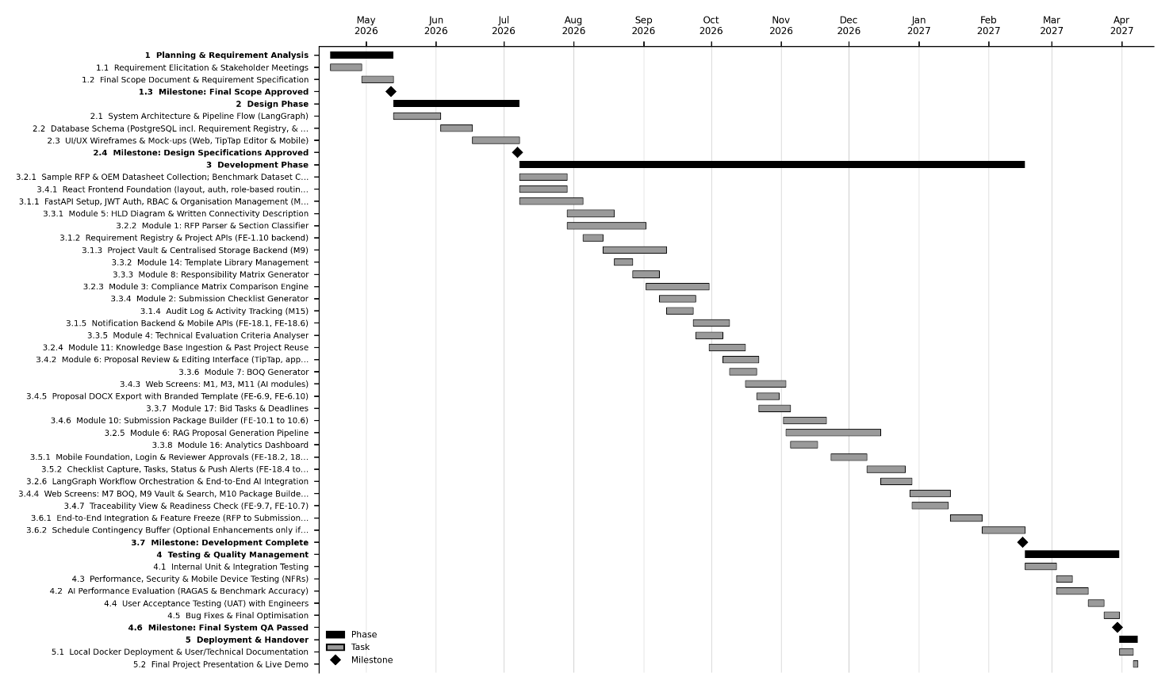
GANTT CHART

Mockups

Mockup 1

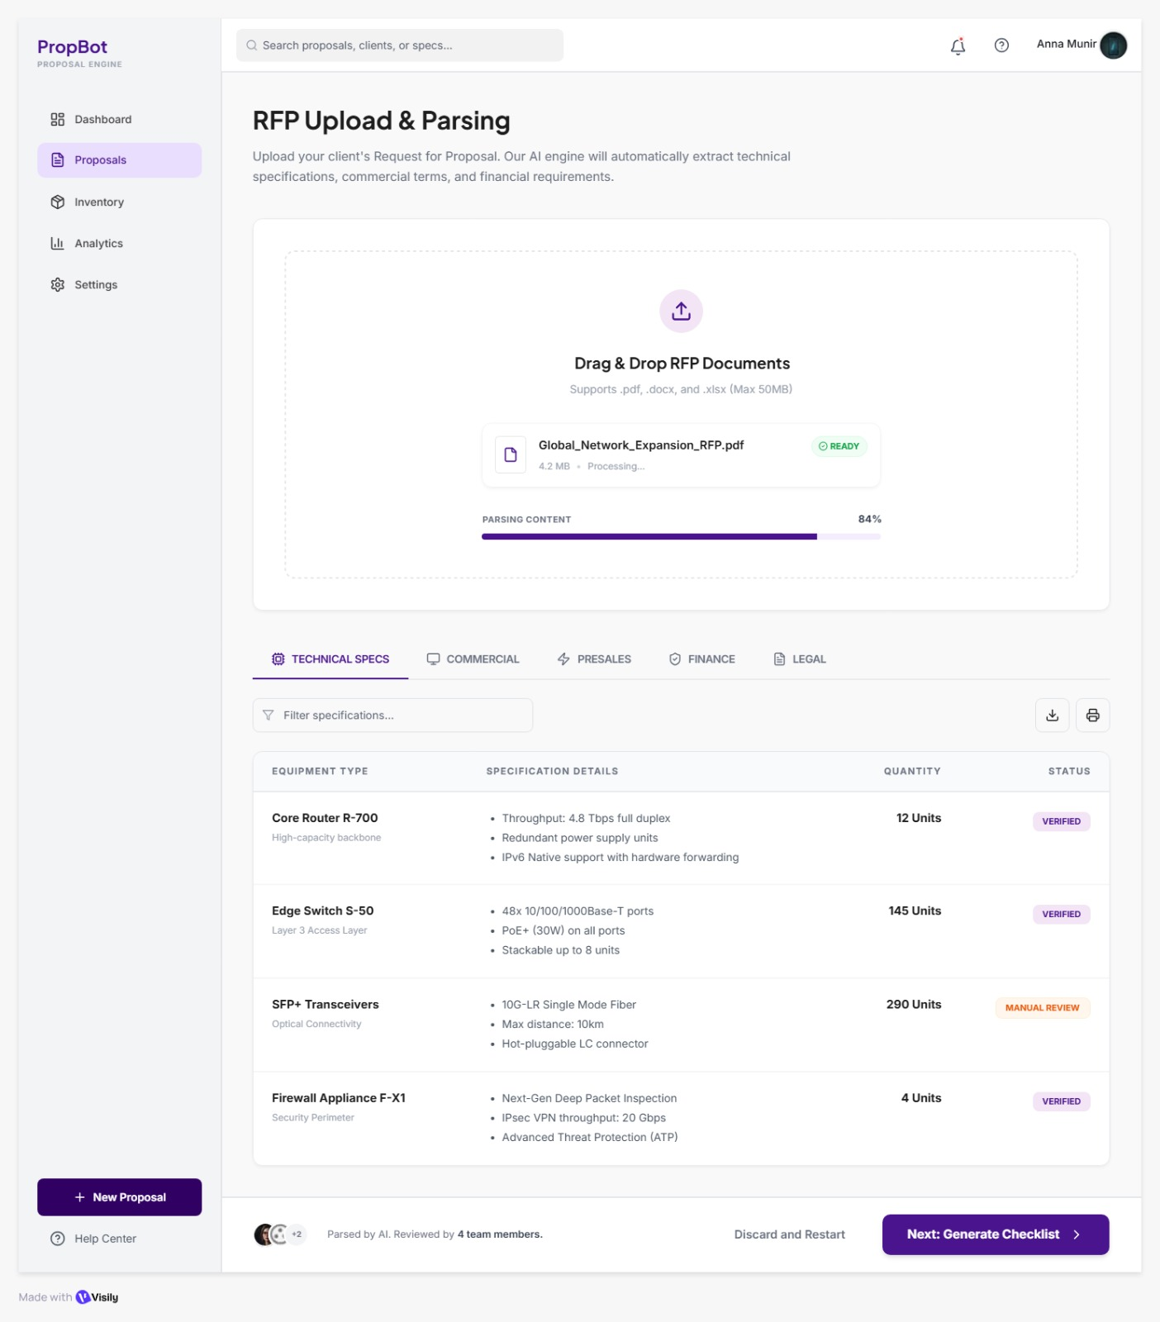
Figure 1: RFP upload and parsing

Mockup 2
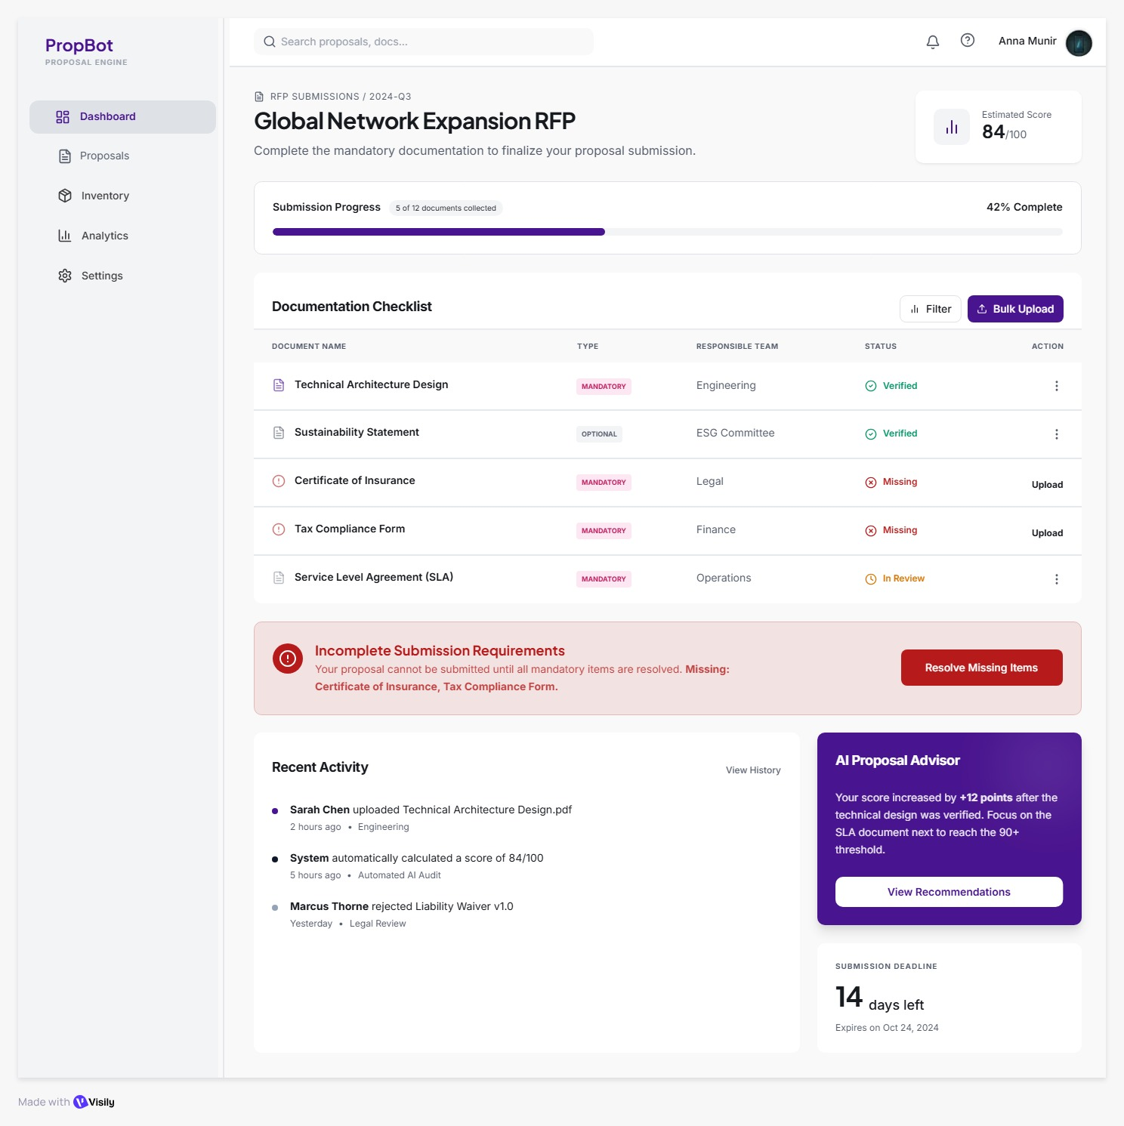
Figure 2: Submission Checklist

Mockup 3
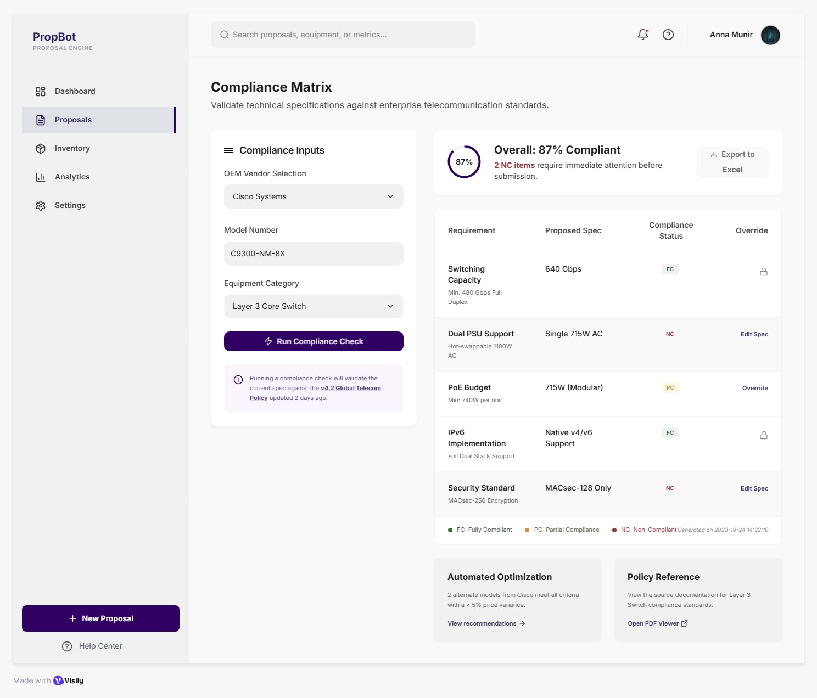
Figure 3: Compliance Matrix Screen

Mockup 4

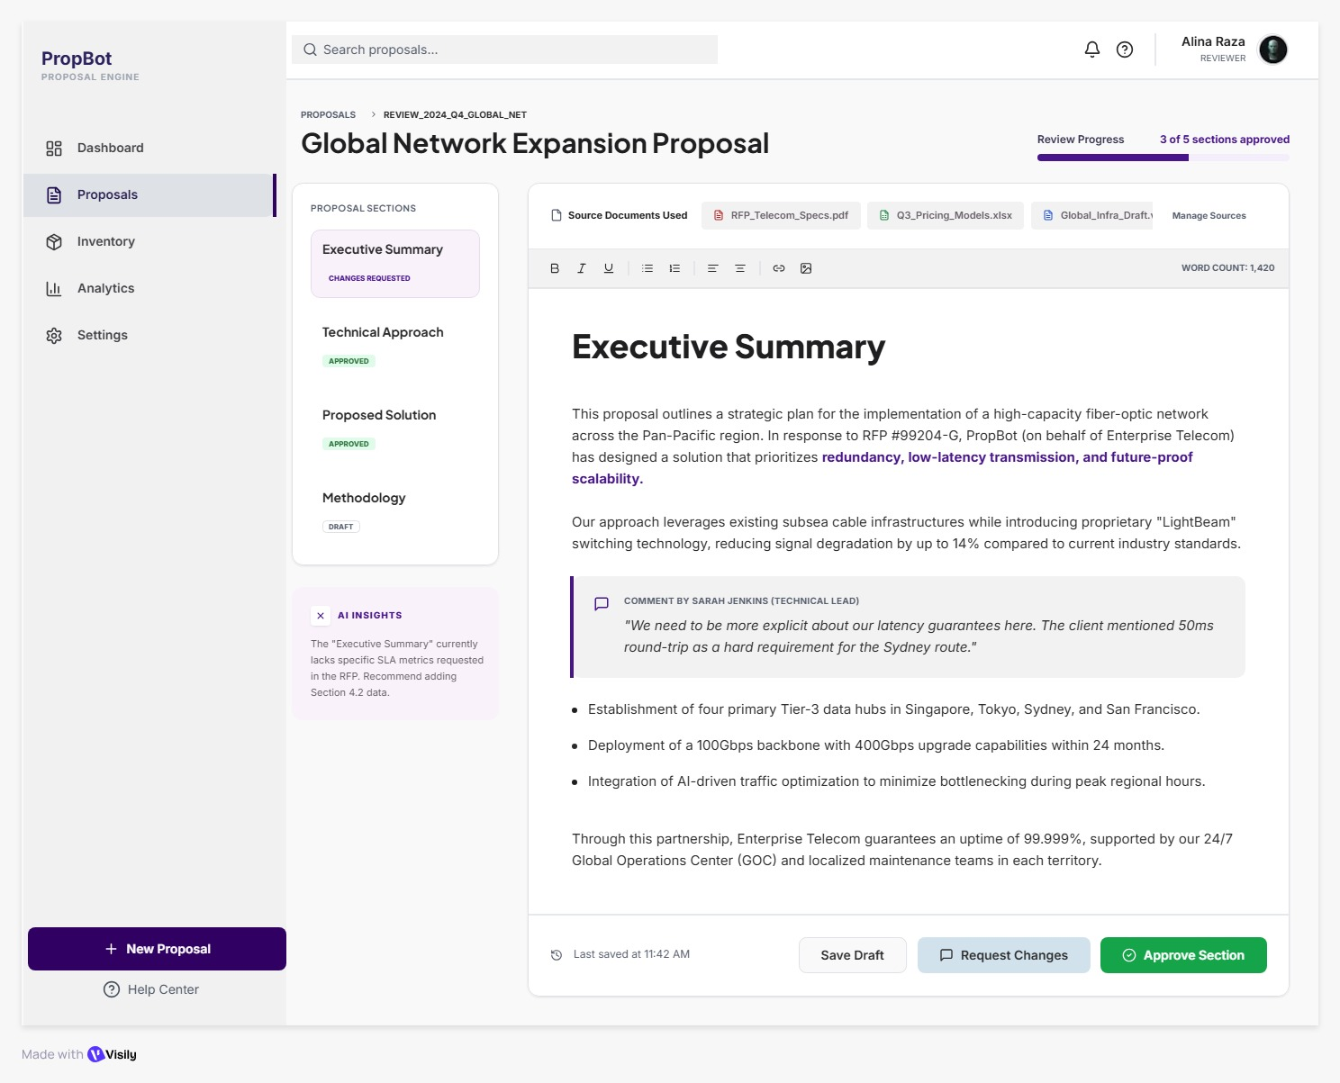
Figure 4: Proposal Review Editor

Mockup 5
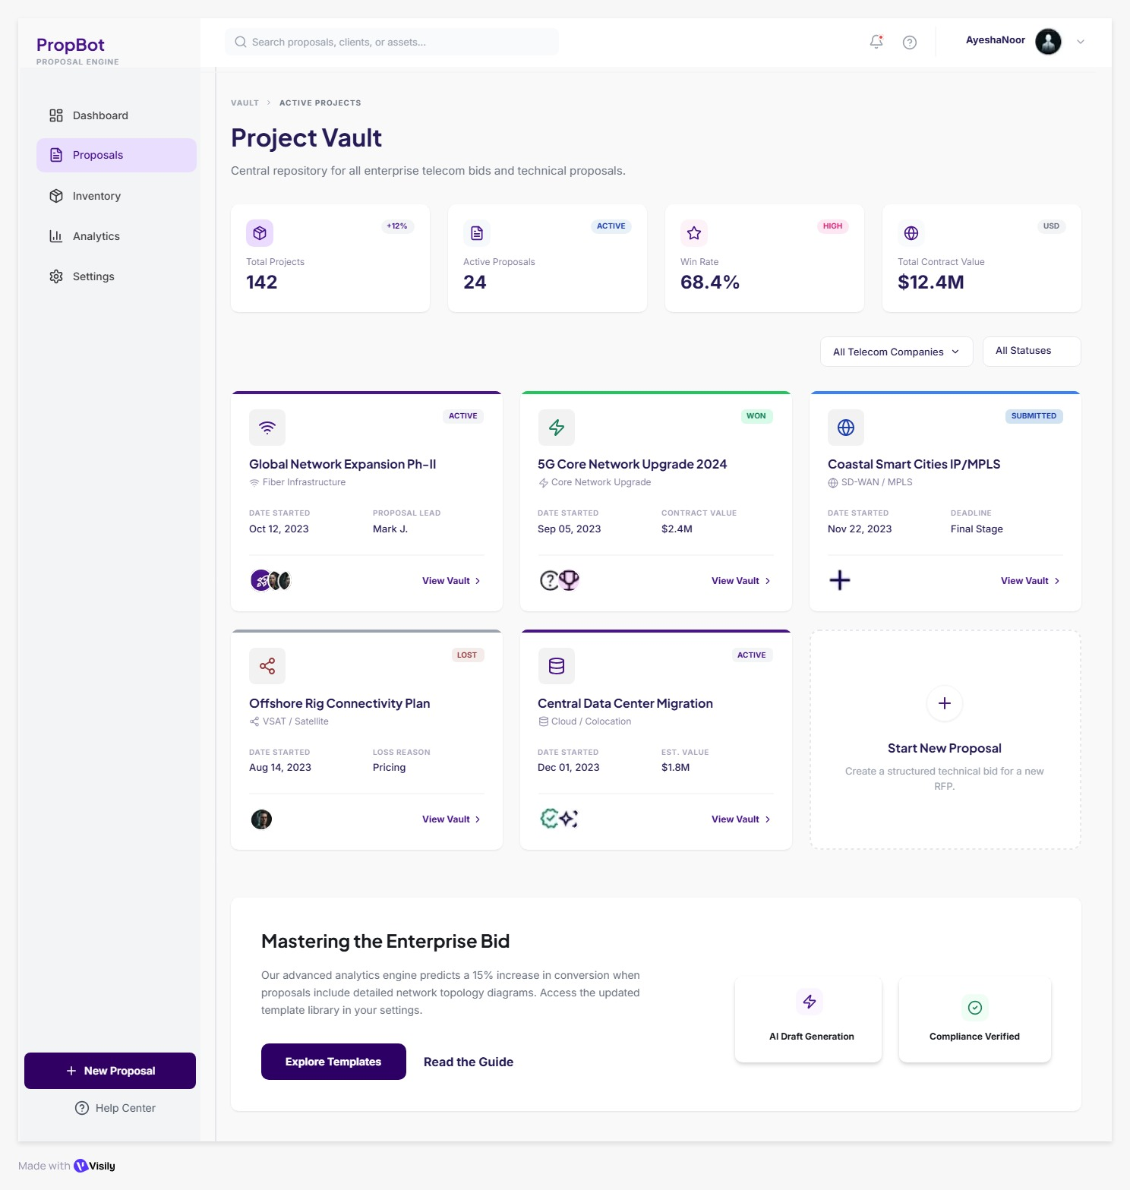
Figure 5: Project Vault Dashboard

Mockup 6

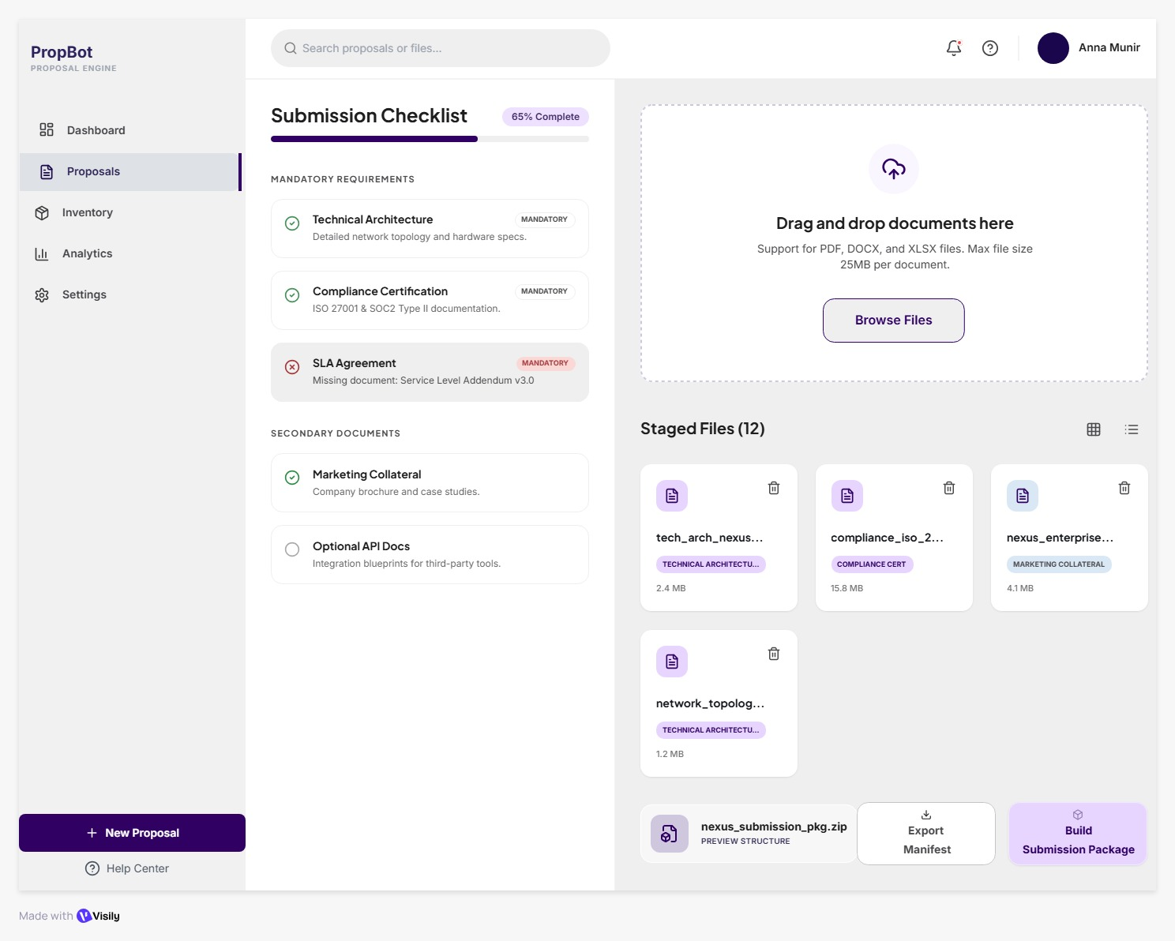
Figure 6: Submission Package Builder

Mockup 7

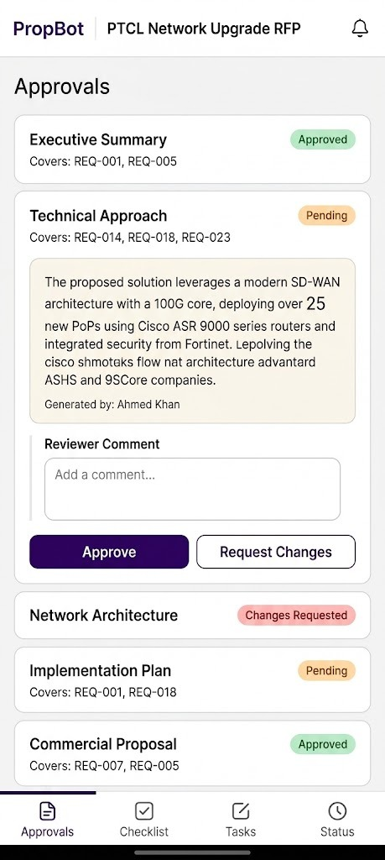

Figure 7: Mobile reviewer approval screen

Mockup 8

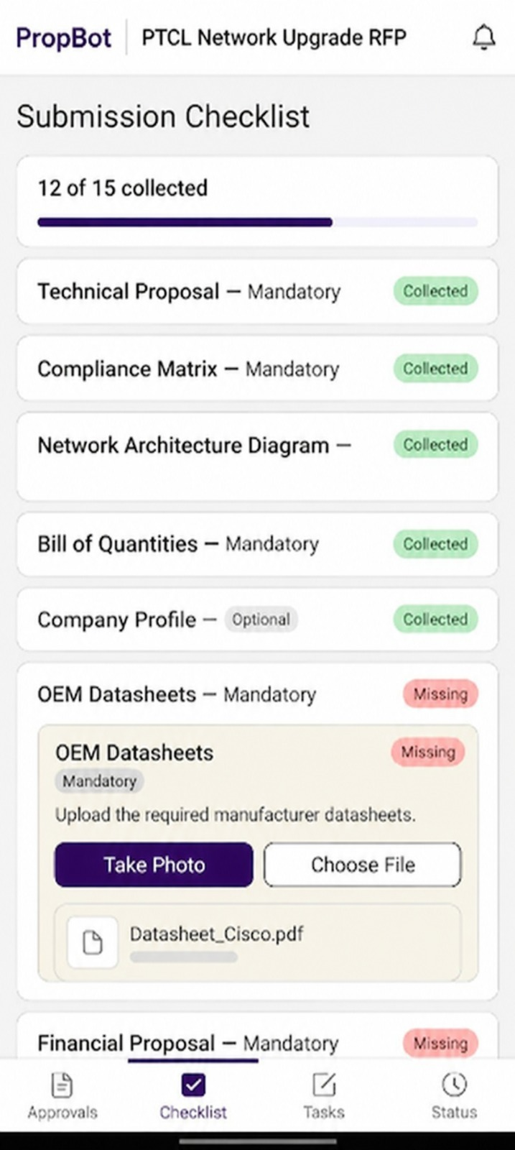

Figure 8: Mobile checklist document capture

Mockup 9

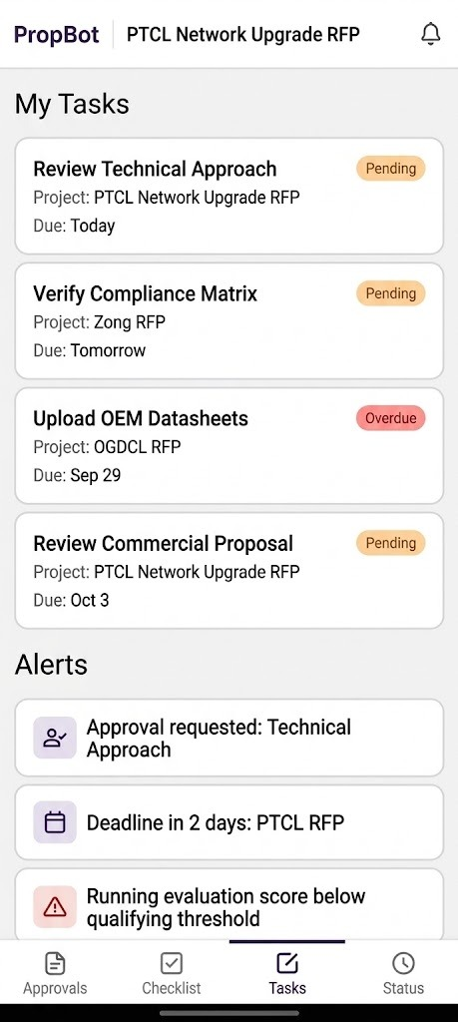

Figure 9: Mobile tasks and alerts

References
- P. Lewis, E. Perez, A. Piktus, F. Petroni, V. Karpukhin, N. Goyal, H. Küttler, M. Lewis, W.-t. Yih, T. Rocktäschel, S. Riedel, and D. Kiela. "Retrieval-Augmented Generation for Knowledge-Intensive NLP Tasks." *Advances in Neural Information Processing Systems (NeurIPS)*, vol. 33, pp. 9459–9474, 2020.

- S. Es, J. James, L. Espinosa-Anke, and S. Schockaert. "RAGAS: Automated Evaluation of Retrieval Augmented Generation." *arXiv preprint arXiv:2309.15217*, Sept. 2023. Internet: https://arxiv.org/abs/2309.15217 [accessed April 2026].

- LangChain Team. "LangChain Documentation — Build AI Applications with LLMs." Internet: https://python.langchain.com/docs [accessed April 2026].

- Chroma Team. "ChromaDB: The AI-Native Open-Source Embedding Database." Internet: https://docs.trychroma.com [accessed April 2026].

- OpenAI. "GPT-4o-mini and text-embedding-3-small API Documentation." Internet: https://platform.openai.com/docs [accessed April 2026].

- S. Tiangolo. "FastAPI: Modern, Fast Web Framework for Building APIs with Python." Internet: https://fastapi.tiangolo.com [accessed April 2026].

- PostgreSQL Global Development Group. "PostgreSQL 15 Documentation." Internet: https://www.postgresql.org/docs/15 [accessed April 2026].

- shadcn. "shadcn/ui: Beautifully Designed Components Built with Radix UI and Tailwind CSS." Internet: https://ui.shadcn.com [accessed April 2026].

- TipTap Team. "TipTap: The Headless, Framework-Agnostic Rich Text Editor." Internet: https://tiptap.dev/docs [accessed April 2026].

- Pakistan Public Procurement Regulatory Authority. "PPRA Public Procurement Portal." Internet: https://www.ppra.org.pk [accessed April 2026].

- World Bank. "World Bank Documents and Reports." Internet: https://documents.worldbank.org [accessed April 2026].

Plagiarism Report
